Why You Should Donate to the Against Malaria Foundation

(Or a Similar Charity)

*Main Points:*

* Will probably save at least one life for each $20,000.
* About 77% of lives saved are kids under the age 5.
* Probably more cost-effective than charities helping people in the US by a factor of at least 75.
* Helps people in sub-Saharan Africa which is the region with the lowest income in the world with a GDP per capita 40 times less than the US.
* Good ratings on charity rating sites.
* Lots of photos, videos, and data on their web site as evidence that they are doing what they say they are doing.
* Each dollar spent this way probably improves the GDP of Africa by about $12.
* Many charity rating organizations give it good reviews. For more information, see Appendix C.

**Why an African Health-Oriented Charity?**

For anyone who likes to donate to charities, I would like to recommend giving to a health-oriented charity that helps people in sub-Saharan Africa. After looking into this quite a lot (including getting a bachelor's degree in global health), I think many of those charities are more cost-effective than charities that help people in the United States by a factor of at least 75. Almost all the lowest income countries in the world are in sub-Saharan Africa. The average GDP per capita of sub-Saharan Africa in 2022 was $1690 (MacroTrends, n.d.) while the GDP per capita of the US is about $70,000 (DataCommons, n.d.), making the United States about 40 times as rich as sub-Saharan Africa. This extreme lack of money in sub-Saharan Africa makes money spent there that much more valuable.

**The Against Malaria Foundation**

In particular, I would like to suggest donating to a charity called the Against Malaria Foundation (<https://www.againstmalaria.com/>). It provides insecticidal bednets for people to sleep under at night to avoid being bitten by mosquitos and infected with malaria. Mosquitos can spread malaria by biting humans and the type of mosquitos that carry malaria especially tend to bite people at night while they are in bed. Malaria is especially dangerous for young kids. 619,000 people died of malaria in 2021 (WHO, Fact sheet about malaria., n.d.) and about 77% were children under the age of 5 years old (UNICEF Data, 2023). Most of the people impacted by malaria live in sub-Saharan Africa (UNICEF Data, 2023). Sleeping under an insecticidal bednet reduces the chances of getting malaria by 50% (UNICEF Supply Division, 2022). The cost of an individual bednet is about $2 (Against Malaria Foundation, 2023), but there are other costs involved in distributing bednets. Overall, I have seen estimates for the cost to save a single life through insecticidal bednets that are as low as $2,800 (GiveWell, n.d.), but none that are more than $20,000.

Another nice thing about the Against Malaria Foundation is that it provides pretty good evidence that it is actually doing what it says it is doing. On its web site, it has details here <https://www.againstmalaria.com/Distributions.aspx> about everywhere that bednets have been distributed. It also has lots of images and videos of the bednet distribution process here <https://www.againstmalaria.com/PhotosAndVideo.aspx>, separated by where and when the distribution took place. The web site emphasizes that all donated money goes towards buying bednets for $2 each, but that's kind of irrelevant because there are lots of other costs involved with distributing the bednets that are not included in that $2 and the only way it is possible for those bednets to be distributed and be effective is with the addition of money from other sources. The primary source of that other money is an organization called "The Global Fund to Fight AIDS, Tuberculosis and Malaria" (Frederick, 2021), which gets most of its money from national governments throughout the world, especially the United States (KFF, 2023).

**GiveWell and Other Options**

When it comes to health-oriented charities that help people in sub-Saharan Africa, the Against Malaria Foundation is not the only option. In particular, there is a web site called GiveWell (<https://www.givewell.org>) that tries to find the most cost-effective charities in the world and recommends them to potential donors. There is quite a lot of information on the GiveWell web site explaining why to donate money to one charity or another. GiveWell also has a spreadsheet (see Appendix A for the URL) that does a pretty thorough cost-benefit analysis for the primary charities that they recommend. Currently, there are four main charities that GiveWell is recommending. The Against Malaria Foundation, which I discussed above, distributes insecticidal bednets. The Malaria Consortium's Seasonal Malaria Chemoprevention Program distributes medicine to help prevent malaria. Helen Keller International's Vitamin A Supplementation Program gives Vitamin A supplements to children with Vitamin A deficiencies, preventing deaths. And New Incentives gives small cash incentives to parents and caregivers in northern Nigeria to encourage them to get their children vaccinated against common illnesses. If you want to donate to any of these charities, you can do it through the GiveWell web site (https://www.givewell.org/charities/top-charities). All four of these charities seem good to me, but I especially like how much information and how many pictures and videos the Against Malaria Foundation provides as evidence that it is doing what it says it is doing.

GiveWell estimates that their four top charities will save a person's life for the cost of between $4,000 and $5,500 and their cost-benefit analysis is pretty thorough, although even they say that it is only approximate. If you would like more specific information about how GiveWell came up with those estimates, see Appendix A for my explanation of their spreadsheet that shows where their estimate for the Against Malaria Foundation comes from. Another estimate of how much it costs to save a life this way can be calculated based on some numbers from the World Malaria Report that the World Health Organization released for 2022. That estimate comes out to $9,500 per death averted. For more specific information about that calculation, see Appendix B.

**A Factor of 75**

I would like to explain where I came up with the estimate that donating to a charity like the Against Malaria Foundation is at least 75 times as cost-effective as charities that help people in the United States. One measurement of the impact of a health-related service is a Disability-Adjusted Life Year (DALY). A single DALY is equivalent to the loss of 1 year of life for a person that is not at all disabled. For a person that is considered to be 50% disabled (meaning their life is half as good as it would normally be), a single DALY would be equivalent to the loss of 2 years of life instead. Similarly, a single DALY would be equivalent to becoming 50% disabled for 2 years (WHO, Disability-adjusted life years (DALYs), n.d.). The charity organization Giving What We Can estimates that the number of DALYs averted by saving the life of a child under 5 years old in sub-Saharan Africa is about 44 (Capriati & Hillebrandt, 2016). If we assume that the cost for the Against Malaria Foundation to save the life of a child under 5 years old is about $20,000 (I haven't found an estimate greater than $20,000), then the cost per DALY would be $455. According to one medical article (Daroudi et al., 2021), the estimated cost per DALY averted in countries that are very high on the Human Development Index (HDI) like the United States is $69,499, which is greater than $455 by a factor of about 150. According to another article (Health Affairs, n.d.), the cost per DALY averted for health services in the United States across all causes of disease between 1996 and 2016 was $114,339 which is greater than $455 by a factor of about 250. Also, in an interview, the founder of The Against Malaria Foundation estimated that in developed countries like the US, health systems spend about $35,000 to $50,000 to increase the lifespan of a person by 1 year which is between a factor of 77 and a factor of 110 (Frederick, 2021). My estimate of a factor of at least 75 comes from these 3 sources.

**Additional Benefits**

There are a couple additional benefits of donating to the Against Malaria Foundation. Firstly, donating to the Against Malaria Foundation and the other three charities on GiveWell's top charities' list primarily prevents the deaths of young kids rather than adults (UNICEF Data, 2023). From a fairness perspective, adding a year of life to a child under five years old seems preferable to adding a year of life to an older person because it is helping the person that has less rather than the person that has more. Additionally, saving the life of a younger person is likely to extend that person's life by more years than saving the life of an older person. There are also economic benefits of preventing malaria infections. GiveWell estimates that the economic benefits from bednets are about 55% as valuable as the direct benefit of preventing deaths (GiveWell, n.d.) and the Against Malaria Foundation itself estimates that every $1 million spent through them improves the GDP of Africa by $12 million (Giving What We Can, n.d.).

**Giving Locally**

One argument I have heard against donating to charities like the Against Malaria Foundation is that people would rather donate to a local charity that helps their community. I can understand wanting to help your community, but not if by doing that, you need to sacrifice almost 99% of the positive impact to do it (74/75 = 98.66%). Additionally, if you are giving to charities that help people in the United States, you are most likely donating to the rich, not the poor. The median household income in the United States is about $75,000 (Guzman & Kollar, 2023), but the worldwide median household income is about $10,000 (Phelps & Crabtree, 2023). The minimum wage in the US is currently $7.25 per hour which is about $14,000 per year if the person is working full time (Statista Research Department, 2023). So even people making minimum wage are actually rich and, by giving locally, you are donating to other rich people (even if they are not as rich as you are).

**Misgivings**

Although I recommend donating to the Against Malaria Foundation and the similar charities on the GiveWell web site, I do have several misgivings about it. Just in case you happen to have similar misgivings, I would like to explain them and why I recommend giving to these charities anyway.

Although GiveWell's estimates are thorough, I'm not sure that they are accounting for all the costs that are associated with distributing the bednets and making sure that they are effective. In particular, parts of the distribution process might involve work that is done by unpaid volunteers or by workers that are paid, but not by the Against Malaria Foundation and I don't know if GiveWell's cost estimates account for this. Not only is labor required to physically deliver the bednets, but it is also required to teach people how to use them and why they are needed. It is also necessary to track where new bednets are needed, where old bednets are wearing out and need replacement, and whether or not they are actually being used. Labor is required to give surveys to collect all that data. Labor is needed at organizations like the World Health Organization and The Global Fund to provide oversight and manage the distribution of funds. There could also be health centers and warehouses or other facilities that are being used that have costs that GiveWell's analysis doesn’t include. Additionally, there may have been volunteers that did work that was necessary to encourage people to donate to the Against Malaria Foundation and if they hadn't been helping this charity, they could have done something else useful instead, so that is another opportunity cost that GiveWell is probably not accounting for.

Additionally, as the need for bednets is met, the benefit from each bednet distributed is likely to have diminishing returns. The first bednets distributed are likely sent to the places that need them the most and then each set of additional bednets distributed would probably have a less efficient impact. GiveWell's cost analysis is for all the bednets distributed, from the first to the last, but additional funding would probably be closer to being as cost-effective as the later, less cost-effective distributions of bednets. However, the estimate that I calculate in Appendix B based on numbers from the World Health Organization doesn't have this drawback.

These diminishing returns and additional costs might make the cost to save a life higher than it would otherwise be, but I don't think they could have that much of an impact, so I would still estimate that these charities are at least 75 times as cost-effective as charities that help people in the United States.

**Appendix A: GiveWell’s Cost-Effectiveness Analysis for the Against Malaria Foundation**

GiveWell has a pretty thorough cost analysis for some of its top charities including the Against Malaria Foundation in a spreadsheet online.

If you want to look at it, you can reach it by clicking the 'View' link on this page: https://www.givewell.org/how-we-work/our-criteria/cost-effectiveness/cost-effectiveness-models

This direct link might also work: https://docs.google.com/spreadsheets/d/1otZFJSMM8yH5R6DkBIYmlsWy5T7VHsX_E7wDF7HSLaM/edit#gid=1364064522

That spreadsheet can be difficult to understand, so the following is an explanation of GiveWell's cost analysis for the Against Malaria Foundation's program in the Democratic Republic of the Congo (DRC) specifically. Hopefully, this will help you understand GiveWell's cost analysis more easily and make it seem less complicated. However, this probably isn't relevant to you unless you really want to see the details of how donations to the Against Malaria Foundation can save lives as cheaply as they seem to be able to.

Their cost analysis starts with cost. They simplify the calculation by only looking at $100,000 of the amount that the Against Malaria Foundation spent in the DRC. They then add in money spent by other organizations ($98,449) and divide by the total number of bednets distributed, ending up with a cost per bednet of $5.85 which should include all costs of distributing each bednet.

They then adjust for the portion of bednets that don't actually end up being used for one reason or another which they estimate as 37% and the average number of people sleeping together under each bednet which is 2.2. This results in a total of 45,970 people sleeping under bednets.

Next, they account for how long bednets take to wear out (1.74 years) before they require replacement and also the cases when a replacement is given but not actually needed (3%). This results in 77,744 person-years of bednet coverage for the $198,449 total cost.

The mortality rate of malaria for young kids is much worse than for older kids and adults, so they calculate the number deaths of kids under 5 that were averted separately from the number of children and adults that are at least 5 years old. They estimate that about 16% of those sleeping under bednets are kids under 5 years old, resulting in 12,086 person-years of bednet coverage for them. I don't understand how they calculated it, but they estimate that 4.46 deaths are everted for every 1,000 kids that sleep under a bednet for 1 year so 12,086 person-years of bednet coverage should result in about 54 deaths averted for kids under 5. Another calculation for people that are at least 5 years old results in an estimate of 13 deaths averted for them. That is a total of 67 deaths averted with about 80% of them being kids under 5 years old.

Taking the total cost of $198,449 and dividing by 67 deaths averted, they end up with a cost per death averted of about $2,977. They estimate that non-perfect monitoring of results makes the bednets about 96% as effective as they would otherwise be, reducing the total number of deaths averted from 67 to 64. This would result in a cost per death averted of about $3,101, but they account for a few misc. issues that they think cumulatively increase the cost by 50%. Also, there is the possibility of this funding displacing existing funding from other sources (this is called funging) which they think increases the effective cost by 5%. They end up with a final cost of $4,916 per death averted.

They also do a calculation estimating the economic/development benefits of the bednets beyond the lives that they can save, and they estimate that those benefits are worth about 55% as much as the deaths that are averted.

**Appendix B: Estimating Cost-Effectiveness Based on the 2022 WHO World Malaria Report**

Another estimate of how much it costs to save a life by donating money to a malaria-related charity like the Against Malaria Foundation can be calculated based on some numbers from the World Malaria Report that the World Health Organization released for 2022.

In the 2022 World Malaria Report, the WHO said that, in total, the world spent $3.5 billion on health interventions for malaria in 2021. It estimated that in order to stay on track for the goals laid out in the WHO's Global Technology Strategy for Malaria for 2016-2030 in 2021, the world would have had to spend $7.3 billion in 2021 (WHO, World malaria report 2022, 2022, p. xxiv).

Looking at the Global Technology Strategy for Malaria, targets for reductions in deaths from malaria compared to 2015 were -40% for 2020, -75% for 2025, and -90% for 2030 (WHO, Global technical strategy for malaria 2016–2030, 2015, p. 8). Laying out those points on a graph and finding a best fit curve, that puts the target reduction at -50% for 2021 compared to 2015.

The number of deaths from malaria in 2015 was about 438,000 (WHO, Fact sheet: World malaria report 2015, 2015). Reducing that by 50% would put the Global Technology Strategy target for 2021 at 219,000. The actual number of deaths from malaria in 2021 was about 619,000 (WHO, Fact sheet about malaria, 2023). So, the implication is that in 2021 an increase in funding from $3.5 billion to $7.3 billion (which would be $3.8 billion) could have averted 400,000 deaths (619,000 - 219,000). Dividing $3.8 billion by 400,000 deaths is about $9,500 per death averted.

I like this estimate because it's based on numbers from the World Health Organization, which probably has more resources to devote to these estimates than the people running the GiveWell web site. One reason that this estimate might be higher than other estimates is diminishing returns. The first bunch of bednets and other health interventions that prevent or treat malaria will tend to be distributed wherever they are most needed, but as more resources are applied, they will tend to be distributed where the need is less and will likely be less effective. This estimate is based on how effective approximately doubling the funding would be and all that extra $3.8 billion would probably be less efficiently applied than the first $3.5 billion and the WHO's estimate very likely accounts for this (WHO, World malaria report 2022, 2022).

**Appendix C: Charity Reviews**

If you would like to see reviews of this charity online by other organizations, they are listed below. Some of these charities also mention that the Against Malaria Foundation does not have as much financial transparency as would be required for the charity rating organizations to review it more fully, but they still give it positive reviews.

* Charity Navigator gives it 100% and a four-star rating.
  + <https://www.charitynavigator.org/ein/203069841>
* GiveWell shows it as one of four of it's top charities.
  + <https://www.givewell.org/charities/top-charities>
* Giving What We Can says it is a top-rated charity.
  + <https://www.givingwhatwecan.org/en-US/charities/against-malaria-foundation>
* The Life You Can Save has many positive things to say about it.
  + <https://www.thelifeyoucansave.org/best-charities/against-malaria-foundation/>
* Great Non-Profits has a lot of 5-star reviews for it from donors.
  + <https://greatnonprofits.org/org/against-malaria-foundation-us>
* Charity Intelligence Canada says it is a 4-star charity that gets a reporting grade of A.
  + <https://www.charityintelligence.ca/charity-details/908-against-malaria-foundation-canada>
* Open Philanthropy recommended a $6.6 million grant be given to it.
  + <https://www.openphilanthropy.org/grants/against-malaria-foundation-general-support-2020/>

**Appendix D: Pictures**

Almost every person I got feedback from while I was writing this document suggested including pictures for the emotional impact. So here are some pictures from the Against Malaria Foundation’s web site of African kids with the insecticidal bednets that should help keep them alive.

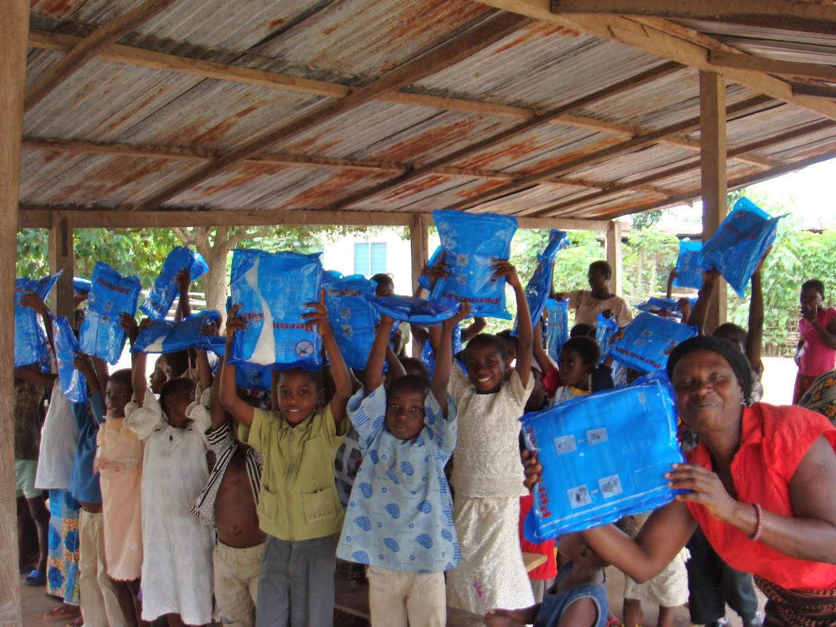.

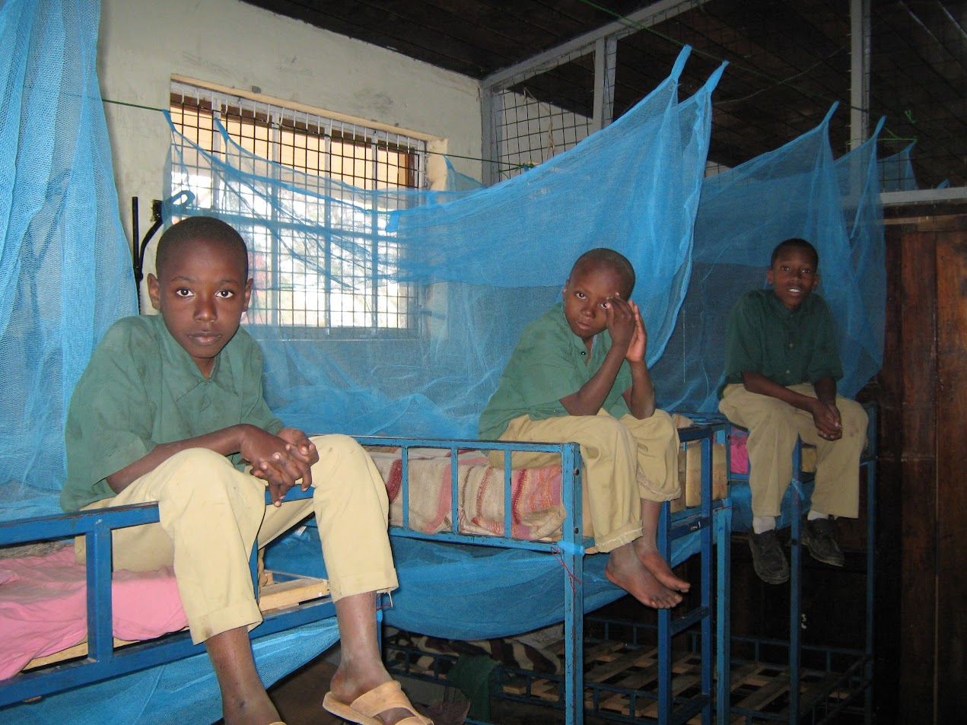

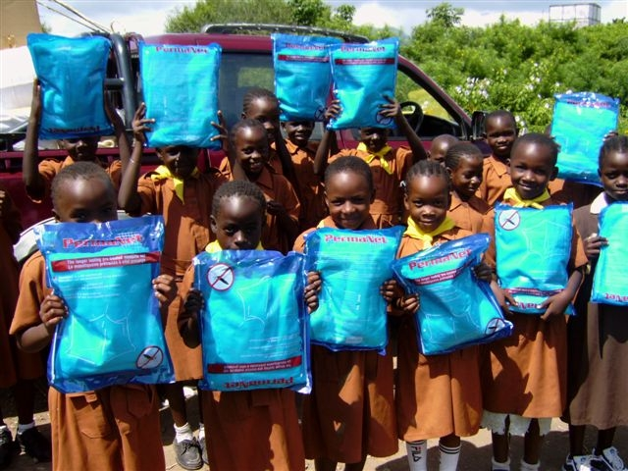

**References**

Capriati, C., & Hillebrandt, H. (2016, June 19). *Report, Against malaria foundation*. Giving What We Can. https://www.givingwhatwecan.org/en-US/reports/against-malaria-foundation

Daroudi, R., Sari, A. A., Nahvijou, A., & Faramarzi, A. (2021, February 4). *Cost per Daly averted in low, middle- and high-income countries: Evidence from the global burden of disease study to estimate the cost-effectiveness thresholds - cost effectiveness and resource allocation*. BioMed Central. https://resource-allocation.biomedcentral.com/articles/10.1186/s12962-021-00260-0

Data Commons. (n.d.). https://datacommons.org/ranking/Amount_EconomicActivity_GrossDomesticProduction_Nominal_PerCapita/Country/northamerica?h=country%2FUSA&unit=%24

*Fact sheet about malaria*. World Health Organization. (2023, March 29). https://www.who.int/news-room/fact-sheets/detail/malaria

*Fact sheet: World malaria report 2015*. World Health Organization. (2015). https://www.emro.who.int/malaria/rbm-news/fact-sheet-world-malaria-report-2015.html

*Fighting malaria with long-lasting insecticidal nets (LLINs)*. UNICEF Supply Division. (2022, February 5). https://www.unicef.org/supply/stories/fighting-malaria-long-lasting-insecticidal-nets-llins

Frederick, D. (2021, May 31). *The against malaria foundation: Lessons from a perennial top-rated charity*. The Business of Giving. https://denver-frederick.com/2021/05/31/the-against-malaria-foundation-lessons-from-a-perennial-top-rated-charity/

*Givewell’s cost-effectiveness analyses*. GiveWell. (n.d.). https://docs.google.com/spreadsheets/d/18ROI6dRdKsNfXg5gIyBa1_7eYOjowfbw5n65zkrLnvc/edit

*Global technical strategy for malaria 2016–2030*. PAHO/WHO | Pan American Health Organization. (2015, November 12). https://www.paho.org/en/documents/global-technical-strategy-malaria-2016-2030

Guzman, G., & Kollar, M. (2023, September 12). *Income in the United States: 2022*. Census.gov. https://www.census.gov/library/publications/2023/demo/p60-279.html

*Health Care Spending Effectiveness: Estimates suggest that spending ...* HealthAffairs. (n.d.). https://www.healthaffairs.org/doi/10.1377/hlthaff.2021.01515

*Malaria in Africa*. UNICEF Data. (2023, May 5). https://data.unicef.org/topic/child-health/malaria/

Phelps, G., & Crabtree, S. (2023, September 19). *Worldwide, median household income about $10,000*. Gallup.com. https://news.gallup.com/poll/166211/worldwide-median-household-income-000.aspx

Statista Research Department. (2023, November 3). *Minimum wage by state U.S. 2023*. Statista. https://www.statista.com/statistics/238997/minimum-wage-by-us-state/

*Sub-saharan Africa GDP per capita 1960-2023*. MacroTrends. (n.d.). https://www.macrotrends.net/countries/SSF/sub-saharan-africa-/gdp-per-capita

*Top-rated charity Against Malaria Foundation*. Giving What We Can. (n.d.). https://www.givingwhatwecan.org/charities/against-malaria-foundation

*The U.S. & the Global Fund to Fight AIDS, tuberculosis and malaria*. KFF. (2023, September 22). https://www.kff.org/other/fact-sheet/the-u-s-the-global-fund-to-fight-aids-tuberculosis-and-malaria/

*Why US$2.00 per net?*. The Against Malaria Foundation. (2023, October 1). https://www.againstmalaria.com/dollarspernet.aspx

World Health Organization. (n.d.-a). *Disability-adjusted life years (DALYs)*. World Health Organization. https://www.who.int/data/gho/indicator-metadata-registry/imr-details/158

World Health Organization. (n.d.-b). *Fact sheet about malaria*. World Health Organization. https://www.who.int/news-room/fact-sheets/detail/malaria

*World malaria report 2022*. World Health Organization. (2022, December 8). https://www.who.int/teams/global-malaria-programme/reports/world-malaria-report-2022