Raucous Deployment
Instructions

Installation 2
How to Play 2
Main Menu 2
How to Start a Network Game 4
Character Selection 4
Map View 5
Sending Chat Messages 7
Keys and Input 7
How the Game Works 8
The Objective 8
Resources 8
Player Colors 8
Buildings and Resource Production 9
Character Statistics 9
Damage 10
Capturing Buildings 10
Attacks 10
Attack Primary Effect 11
Attack Effects 11
Attack Area of Effect 11
Selective Surrounding and AOE Attacks 12
Bomber Attacks 12
Experience Levels 12
Character Value 13
Swap Attacks 13
Cooldown Abilities 13
Passive Abilities 14
Character AI 14
Game Playing Tips 14
How to Mod 15
Changing the Mod Specification 16
Character Type Descriptions 16
Building Type Descriptions 18
Changing the Mod Images 19
Image Format 19
Image File Names 19
Special Colors 20

Installation

If you have downloaded the game from the website, you should have downloaded a file with the extension .zip. To install the game, simply unzip this file to a folder of your choice. A new RacDep folder will be created in that folder. If you are looking at these instructions, you have probably already done this. To play the game, run the jar file RacDep.jar in that folder. Depending on your operating system, you may be able to simply double-click the jar file or you may have to type java -jar RacDep.jar at the command line. You will need to have a recent version of a Java Runtime Environment installed on your computer for the game to work. It can be downloaded from http://www.java.com.

How to Play

Main Menu

When you first run the program, you should see the main menu. The main menu has many text fields you can type in and buttons you can click on. Buttons are outlined in white and fields are outlined in orange. To select a text field so you can type in it, click on it. Throughout the game, you may also press the key that is indicated in parentheses next to a field or button to click or select it. You may not always be able to click on or type in a button or field. You can scroll the main menu and most other panels by hovering the mouse inside them and rolling the mouse wheel, using the arrow keys or page up, page down, home or end, or by clicking the scroll arrow buttons that will appear when the panel can be scrolled.

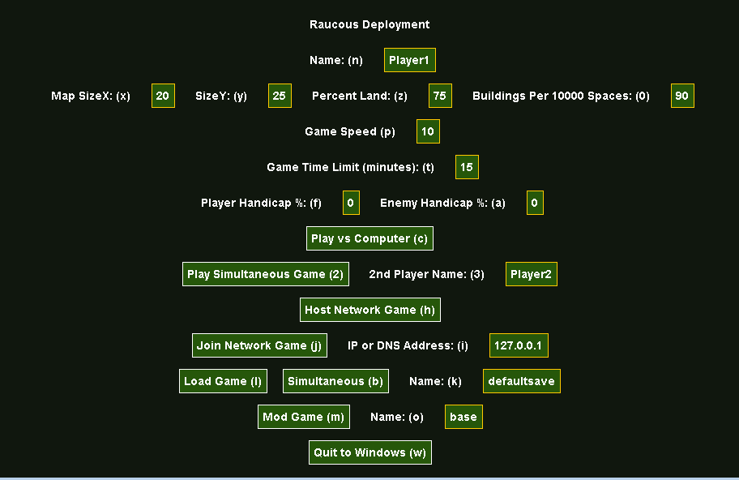
Main Menu

Here is a list of what each main menu option does:

Name: Player 1’s name in the game.
Map SizeX, SizeY, Percent Land, and Buildings Per 10000 Spaces: These options affect how the map will be randomly generated for each game.
Game Speed: How fast the game will go, 10 is a medium speed. If you want to change the speed during a game you will have to click “Set” after you have typed in the new speed.
Game Time Limit: If the game time limit runs out, the game will end and the player with the most total points will win.
Player and Enemy Handicap: These options give bonuses to the resources player 1 and 2 respectively gain and can be used to give one player an advantage.
Play vs. Computer: Starts a game against the computer.
Play Simultaneous Game: Starts a game between 2 players using the same computer.
2nd Player Name: The name of the 2nd player in a simultaneous game.
Host Network Game: Hosts a network game on a LAN or over the internet.
Join Network Game: Tries to join a network game hosted at the address in the text field to the right of this button. This address can be an IP address like “127.0.0.1” or a DNS address like “foo.com”.
Connected Player’s Name: The name of the other player in a network game.
Play Network Game: Starts a network game once you have connected to the other player’s computer.
Resume Game: Closes the main menu and goes back to the game in progress.
Quit Game: Quits the game in progress.
Disconnect: Quits the game in progress if you are in one and disconnects.
Mod Game: Imports the mod with the name in the text field to the right. See the section “How To Mod” for more information.
Unmod Game: Imports the default mod again if a different mod has been imported.
Register: Tries to register the game using the serial number in the text field to the right. If the serial number is valid, this will change the program from a demo to a full version.
Quit to Windows: Exits the program.

How to Start a Network Game

To play a network game, your computer must be connected to the computer of the player you wish to play against either over a LAN (local area network) or over the internet. One player should host the game and the other should join it. The player who will host should start hosting by clicking “Host Network Game” in the main menu. The player who is not hosting will need to know the IP or web address of the player who is hosting and should click on the text field “IP or DNS Address” and type it in. You can find your IP address in most versions of Windows by typing “ipconfig” and pressing enter at the command prompt. The command prompt can usually be accessed from the Start Menu under Accessories. Then the joining player should click “Join Network Game”. Then both players should see a message saying that they have connected. The hosting player will see a new button “Play Network Game” which will start the new game by sending both players to the character selection screen. If you want to disconnect from the network game to play a game vs. the computer or against another player on the same computer, click “Disconnect”.

Character Selection

After starting a new game of any kind, you will see the character selection screen. This screen lets you choose which character types you will be able to deploy in the coming game. To select a character type, click on it. It will then appear in one of the buttons towards the top of the screen. You may click that button or the character type’s button again to deselect it. To exit the character selection screen and go back to the main menu or the previous character selection screen, click “Cancel”. When you are done selecting character types, click “Done” to start playing the game or move to the next player’s character selection screen.
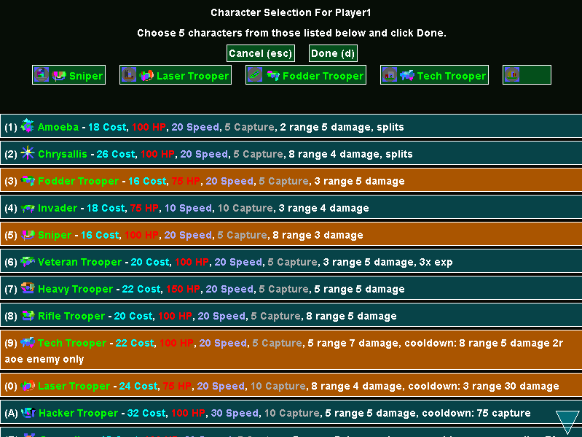

Character Selection Screen

Map View

After you are done with character selection, you will see the map view. The map view is where the game takes place.

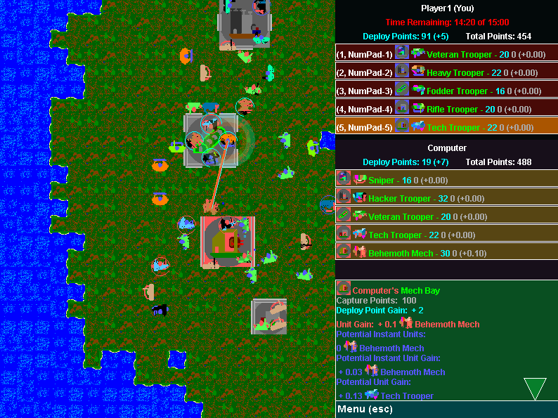
Map View

You can view what is happening in the game in the map panel on the left. You can scroll the map using the arrow keys if you aren’t playing a simultaneous game or by moving the mouse near the edges of the screen or window in windowed mode.

In the bottom right corner of the screen, there is a “Menu” button. This button can be clicked to open the main menu. The game will automatically pause when the main menu is opened or a short time afterwards if you are in a network game.

If you are playing a network game, the game will start out paused and will unpause a short time after both players have finished character selection.

On the right side of the screen there is a panel with player statistics and a button for each character type for each player. You can click on a character type to select it for deploying on the map. The button for each character type shows how much the character costs in deploy points in light blue and how many of that character type you could deploy for free in gray.

In the bottom right corner of the screen, there is a box that can display information about character types and buildings. To see information about a building, right click on it on the map. To see information about a character type, right click on a character type button on the right side of the screen. Note that you can right click on character types in your enemy’s player panel as well as your own. You can’t right click on characters in the map panel to see information about them.

To deploy a character, select a character type by clicking on it in your player panel and then click where you want to deploy the character on the map. If you move your mouse over the map panel while you have a character type selected, a mostly blackened image of the character type will appear where the character would probably be deployed if you clicked. The character may not start deploying immediately if you are playing a network game, but should start deploying soon. Then you will see the character where you deployed and the yellow deploy halo will start to unfill around the new character. When the halo is gone, the character will be done deploying, but will still wait a short time longer until it becomes active. You do not control characters in any way after they are deployed. The characters will decide for themselves where to go and what to do. You only decide when and where to deploy them.

You can pause the game by pressing P or, if not playing a simultaneous game, spacebar. Pressing P or spacebar again will un-pause the game.

Simultaneous: if you are playing a simultaneous game as the 2nd player, you may interact with the map view in the same ways as the first player, but you will use the keyboard instead of the mouse and different keys on the keyboard.

Sending Chat Messages

When you are connected to a network game, you may send chat messages to the other player by pressing enter, typing a message, and then pressing enter again to send the message. While you are typing the message, a field with the message in it will appear below the message box at the bottom of the screen. If you want to stop typing a message without sending it, press the escape key. When you send a message, it will show up in the message box and when the other player receives your message, it will also show up in his message box. If you type an empty message without even any spaces in it, it won’t be sent to the other player.

Keys and Input

Left Mouse Click: Selects or deselects text fields, activates buttons, and attempts to deploy characters on the map.
Right Mouse Click: Deselects text fields and shows information about character types in player panels and buildings on the map.
Mouse Wheel: Scrolls the panel the mouse is hovered over.
Moving the Mouse: The map panel will scroll if the mouse stays near the edge of the screen (or window in windowed mode).
Arrow Keys: Scrolls the panel the mouse is hovered over or moves the 2nd player’s cursor in a simultaneous game.
Home, End, Page Up, Page Down: Scrolls the panel the mouse is hovered over.
P: Pauses and un-pauses the game.
Spacebar: Pauses and un-pauses the game. In a simultaneous game, lets the 2nd player click on a character type or on the map panel to deploy a character.
Minus (-) and Equals (=): Decreases and increases game speed respectively.
X: In simultaneous games, allows the 2nd player to right click on character types and buildings to see information about them.
D and C: In simultaneous games, allows the 2nd player to scroll its player and info panels while the mouse is in them.
F1: Toggles between full screen and windowed mode.
Enter: Opens the chat interface for typing and sending chat messages when connected and sends chat messages after they are typed. Deselects text fields on the menu.
Escape: Closes the chat interface for typing and sending chat messages when connected without sending the typed message. Deselects text fields on the menu.
Shortcut Keys: Pressing a key in parentheses next to a text field or on a button will select the text field or activate the button.
Most of Keyboard: Used for typing in the chat interface when it is open and a text field when one is selected.

How the Game Works

The Objective

In a game of Raucous Deployment, you deploy characters of various types on the map in the hopes that they will destroy the other player’s characters and capture buildings. If they are successful, you will capture all of the buildings and destroy all of your enemy’s characters. If a player has no characters on the map for a certain amount of time, they will lose the game. Also, if the game time limit expires, the game will end and the winner will be the player who has a higher total value worth of characters in the game at that time.

Resources

After you have selected a character type, each time you click on the map and a character starts deploying, you will spend resources to deploy that character. If you have ready characters available, those will be spent first, and if not, you will pay the cost of the character in deploy points. If you do not have enough of either of these, you cannot deploy the character. Resources are gained at a steady rate from each building.

Player Colors

The first player’s color is blue and the second player’s color is red. If you are playing a network game, then you will be the first player on your computer and the other player will be the first player on his computer. Characters and buildings and even character types that belong to each player will be partly colored with that player’s color. If a building has not been captured by either player yet, it will be partly colored gray to indicate that it is neutral.

Buildings and Resource Production

If your characters capture buildings, those buildings will give you resources so you can deploy more characters and possibly more characters directly. Buildings give resources in the form of deploy points and ready characters. Each building type is associated with a slot which each player selects a character type for in the character selection screen. An icon of the building type that is associated with the slot appears in the slot’s button both at the top of the character selection screen and in the player panels. Each building produces ready characters for their controlling player of the character type that is that building’s type’s slot. Buildings produce more expensive ready characters slower than cheaper ones. When capturing an enemy building, the building will instantly produce some number of characters for you of the other player’s character type that is associated with the building’s type’s slot. More characters will be created this way the longer the building has been controlled by the enemy. Different building types produce deploy points, ready characters, and capture characters at different speeds.

If you right click on a building in the map panel, you can see information about the building. You will see its controller and the number of capture points it has towards its current controller or the first player if it has not been captured yet (see Capturing Buildings below). You will see the number of deploy points it produces. You will see the number of ready characters it is producing or would produce for each player per round. You will see the number of characters that would be instantly gained by capturing the building from the other player and you will see the rate at which that number is increasing per round.

Different building types have different sizes and wall configuration. Characters can attack over walls, but they cannot move through them. It is easier to capture larger buildings that have fewer walls because more characters can get inside them more easily.

Character Statistics

Each character and character type has a set of statistics and a list of abilities. When viewing character types in the info panel, you will see these statistics and the abilities listed below them. There are 4 statistics and they are as follows:

Cost: The number of deploy points that must be spent to deploy the character without using a ready character.
HP: The maximum and starting number of HP the character has. The character dies when its HP falls to or below 0.
Speed: How many spaces the character can move per round.
Capture: How many capture points the character can apply towards capturing or retaining the building it is in for its controller.

The abilities in a character’s description includes a normal main attack, a swap attack (see Swap Attacks below), or an AI determinant cooldown ability (see Cooldown Abilities below) and any number of additional cooldown abilities and passive abilities (see Passive Abilities below). These will be described later. Ability descriptions are separated by commas. Note that any time these instructions says “separated by commas”, it really means separated by commas followed by spaces, i.e. “, “.

Damage

When characters are attacked, they will usually take damage which reduces their HP. When their HP falls to or below 0, they will die as a spattering of dots. As a character takes damage, parts of it will turn black until almost all of the character is black when it dies.

Capturing Buildings

If one of your characters is inside a building and it is not stunned, it will attempt to capture or retain the building for you. It does this by applying its capture ability. The higher its capture statistic, the more effectively it can do this. Each building has a certain number of capture points at any point in time ranging between -100 and +100. If the building is neutral, it will be captured by player 1 when it has +100 capture points and it will be captured by player 2 when it has -100 capture points. If the building is controlled by a player, it will be captured by the other player when it has -100 capture points. Each time a building is captured, its capture points change to +100. Each round, a character in a building will add or subtract its capture ability towards capturing or retaining the building for its controller.

Attacks

Aside from capturing buildings, characters can also use attacks. Each character type must have an attack whether it is a normal attack, a swap attack which switches between a list of normal attacks (see Swap Attacks below), or an AI determinant cooldown attack (see Cooldown Abilities below). It may also have additional attacks in the form of additional cooldown attacks. The character uses the attack to affect other characters. For information on who is effected by the attack, see Attack Area of Effect. After a character uses a normal or swap attack, it will normally have to not move or attack until a round has passed. Characters with the passive ability (see Passive Abilities below) “moves and attacks” can still move while attacking, but must wait to attack again.

Attack Primary Effect

The primary effect of an attack can be to deal damage, heal HP, or give experience, although not all attacks do a primary effect. If an attack does one of these, the description of the attack will include a number followed by “damage”, “heal”, or “exp”. Damage reduces the effected target’s HP, possibly killing the target if it brings the target’s HP to or below 0. Healing increases the effected target’s HP, but cannot increase it above the character’s maximum HP or heal the dead. If the attack gives experience, the target character will gain experience and possible gain a level (see Experience Levels below).

Attack Effects

Attacks may have additional effects indicated by specific words and phrases in the attack’s description. Here is a list of effects and what they do:
“stun”: Stuns the target for one round during which it may not move, attack, or capture. A character that is currently moving effected by this will continue moving until it reaches the next space.
“poison”: Poisons the target so that it takes 4 damage every round until it dies. If the target uses autorevive, the poison goes away. A character may only be poisoned once at a time, the effect doesn’t stack.
“death count”: Kills the target after 10 rounds.
“take control”: Takes control of the target for the attacker’s controller. Not available in the demo version.
“autorevive”: Allows the target to automatically rejuvenate to full health whenever it dies. A character may only have auto-revived status once, the effect doesn’t stack.
“drain level”: Reduces the target’s level by 1 and increases the attacker’s level by 1. If the target is only level 1, the attacker doesn’t gain a level.

Attack Area of Effect

Various parts of an attack’s description indicate what range it can be used at and generally what characters it affects. The range of an attack is indicated by a number followed by the word “range” at the beginning of the attack description, but surrounding attacks do not have any range. There are 4 types of attacks:
Direct: The attack affects the single target in range that is chosen. This is the default and does not need to be indicated in the attack description.
AOE: The attack affects the target in range that is chosen and characters within the given radius of the chosen target. This is described by a number followed by an ‘r’ followed by “aoe”. The number before the ‘r’ is the given radius.
Surrounding: The attack affects characters within the given radius of the attacker, but not the attacker. This is described by the word “surrounding” replacing the range and a number followed by an ‘r’ followed by “aoe” just like an AOE attack. The number before the ‘r’ is the given radius.
Chaining: The attack affects the target character and then jumps to another target within the given chaining range of that target and then to another target, etc., until there are no targets within range of the last target or the attack has effected the given number of chaining enemies. This is described by a number followed by an ‘r’ followed by another number followed by an ‘e’ followed by the word “chain”. The number before the r is the given chaining range (how far the chain can leap in a single jump) and the number before the ‘e’ is the given chaining enemies (how many targets the chain can jump between). Chaining attacks are not available in the demo version.

Selective Surrounding and AOE Attacks

Some surrounding and AOE attacks only affect friendly or enemy characters. This is indicated in the attack description by the words “friendly only” or “enemy only” after the word “aoe”. Selective surrounding and AOE attacks are not available in the demo version.

Bomber Attacks

Bomber attacks are special attacks that are just like other attacks except that they kill the attacker after the attack and they may only be used if the given number of friendly or enemy (depending on whether they attack is beneficial or harmful) characters are within range (or radius if surrounding attack) of the attacker. A bomber attack is indicated in an attack’s description by a number followed by an ‘e’ followed by the word “bomber” at the end of the attack description. The number before the ‘e’ is the given number of friendly or enemy characters.

Experience Levels

As characters affect other characters in useful ways by damaging, healing, autoreviving, poisioning, death counting, or whatever else, they gain experience. The amount of experience gained depends on the extent of the effect and the relative values (see Character Value below) of the attacker and effected character. The amount of experience gained increases as the extent of the effect increases, increases as the value of the effected character increases and decreases as the value of the attacker increases. If an attacker harms a friend or helps an enemy, the attacker does not gain or lose experience. For every certain amount of experience a character gains, they gain a level. Gaining a level makes the character’s image more colorful, gives the character a bonus depending on the level, and heals the character completely. Note that if a character gains a level using the drain level attack effect, the character does not heal because of it. The maximum level that can be gained is 8 and the minimum and starting level is 1.

Below is a list of the bonus effects from each level. Since some characters have attacks which make bonuses ineffective, multiple possible bonuses are listed for each level, separated by “else”. The first bonus that is applicable will be used when a character gains a level.

Level 2: +30% HP
Level 3: +25% Speed
Level 4: +50% Capture
Level 5: +15% Damage else +15% AOE else +15% Chaining Range else +15% HP
Level 6: +15% Range else +15% Chaining Enemies else +15% AOE else +15% Speed
Level 7: +15% AOE else +50% Capture
Level 8: +15% Chaining Range and Enemies else +15% Speed

Character Value

As characters gain levels, they also gain value. A character’s value starts out as its character type’s deploy point cost. When a character gains a level, the character also gains 25% of their deploy point cost in value. Value affects how much experience a character gains and how much experience characters that affect it gain. The total of the values of all of each player’s characters on the map determines who wins if the game time limit runs out. The total value is also added to the total value of a player’s ready characters and the player’s deploy points to make up the statistic in the player panel “Total Points”.

Swap Attacks

A swapping attack is a primary attack that swaps through a list of attacks each round instead of always using the same one. One of these attacks is an AI determinant attack which means that it helps determine what bonuses the character gains when leveling up instead of the others. A swapping attack is indicated by the word “swap: “ followed by a list of attacks separated by commas inside parentheses. The AI determinant attack is indicated by the phrase “AI determinant” after the attack description. Swapping attacks are not available in the demo version.

Cooldown Abilities

Cooldown abilities are extra abilities which never require the character to stop moving to reload and may be used whenever they are ready, but must cool down for 10 rounds before each use. While cooldown abilities are waiting to be used again, a halo will fill up around the character with the cooldown ability and when it is full, the cooldown ability will be ready for use. A character may have any number of cooldown abilities. A character may have an AI determinant cooldown ability instead of a normal or swapping attack, but not in the demo version. Cooldown abilities can be attacks as described above (although they cannot be swapping attacks), but there are a few non-attack cooldown abilities which are described here:
“spawn”: Creates a new character of the same character type as the character adjacent to the character.
“75 capture”: Applies 75 capture points towards capturing the building the character is inside. Not available in the demo version.
“heal self all HP”: Heals the character to max HP. Not available in the demo version.
Cooldown abilities are indicated in an ability’s description by the word “cooldown:” followed by the attack’s description or the word or phrase that defines a non-attack cooldown ability.

Passive Abilities

Passive abilities are abilities that are used automatically without being guided by a character’s artificial intelligence. Here is a list of them and what they do:
“splits”: Creates a new character of the same character type with the same HP, level, and experience as the character adjacent to the character for every 100 max HP worth of enemies the character kills. Not available in the demo version.
“improve attack”: Gives all characters within 3 spaces of the character a bonus 5 damage to all attacks as long as they stay within 3 spaces of the character. This bonus cannot be applied to the same character multiple times from different characters, the effect doesn’t stack. Not available in the demo version.
“kill control”: Whenever the character kills a character, it instead takes control of the character for its controller and heals it to maximum HP. This effect isn’t used if the killed character recovers using auto-revive.
“moves and attacks”: The character may attack while moving.
“3x exp”: The character gains triple the normal amount of experience when gaining experience.
“drain HP”: The character gains 1 HP for each HP of damage it does.

Character AI

Your characters will try to fight for you and capture buildings, but they are not very smart. There are some things that they understand very well. For example, they won’t try to poison an enemy that is already poisoned. But there are other things that they don’t understand. For example, if a character is next to a building and sees an enemy inside the building, they will not think to move inside the building so they help capture it while attacking the enemy, but instead will probably decide to attack the enemy from outside the building. Characters will also not necessarily stop to attack a character that is attacking it as it goes by, even if it will obviously die before it reaches its objective. When playing the game, do not assume that the characters will always behave as intelligently as you would. Even if you place a character directly next to a building you want it to capture, it may decide to move towards a different objective.

Game Playing Tips

If you are having difficulty winning in the game, here are a few tips that may be able to help you:

You should try to deploy characters as soon as you can. The sooner a character gets into the game, the sooner it can help capturing buildings for you which will give you more characters. At the beginning of the game, feel free to use all of your deploy points very quickly. When playing a game against the computer, you may want to pause and deploy as many characters as you can when you first start the game.

Deploy characters near buildings. This way the characters will have to travel less to start capturing them.

If you see some enemies moving towards one of your buildings or already capturing it, you may want to deploy some characters inside the building, especially at gaps in the building’s walls. This will stop more enemy characters from getting into the building. Also, if the enemies capture the building, your characters will immediately start taking it back when they are finished deploying.

If you see a large cluster of enemy characters, try deploying characters with attacks that can affect multiple characters like chaining, AOE, and surrounding attacks nearby.

More expensive characters usually have the same capture abilities as cheaper characters, so if you want to capture a building quickly when there aren’t very many enemies around, try deploying many cheaper characters instead of fewer more expensive characters.

How to Mod

A mod defines the character types, building types, and images used in a game. By default, the “demobase” mod is used for the demo version of the game and the “base” mod is used for the full version of the game. However, if you would like to change the game, you can create other mods.

Once you have created the new mod, you can import it for use by typing the name of the mod into the text field next to the button “Mod Game” and then clicking that button. To switch back to the default mod, you can click the button “Unmod Game”. If you are currently using the full version of the game, but wish to play the demo version instead, you can do this by typing the name “demobase” into the text field next to the button “Mod Game” and clicking that button.

To create a new mod, you should usually start by copying the “base” or “demobase” mod. Go to the folder where you installed the game. You should see a folder in that folder called “Mods”. In that folder, there is a folder for each mod with the same name as the mod. If you have just installed the game, there should be only 2 folders, “base” and “demobase”. To copy one of these mods, simply copy the folder and rename it. You should try to always give different mods different names because if you play a network game against a player with a different mod of the same name, it could cause the game to lose synchronization. If the game loses synchronization, you will be playing a different game than the other player.

Once you have copied the mod, you will have a new mod which is exactly the same as the one you copied. There are two distinct parts of the mod you can change. The first is the specification file which defines the character types and buildings types and the second is the images which includes images for terrain, buildings, characters, and the simultaneous player’s cursor.

Changing the Mod Specification

The specification file in a mod is simply a text file which can be opened with any plain text editor such as Windows Notepad. It is the text file with the file name “spec.txt” in the mod’s folder. If a specification file does not use the correct syntax or something in the specification is incorrect, an error will be shown in the message box when you try to import the mod. The specification file consists of 3 parts, the map space size, the character descriptions, and the building descriptions. The map space size should be at the beginning of the specification and simply consists of the phrase “Map Space Size:” followed by a space and then a number which must be positive and cannot be zero. This number will be the width and height of each map space in the map panel in pixels on your screen. The map space size should be followed by 2 line breaks and then the character descriptions should be next followed by 3 line breaks and the building descriptions.

Character Type Descriptions

The character descriptions or character type descriptions should start with the phrase “CHARACTER DESCRIPTIONS” in entirely capital letters followed by 2 line breaks. Each character description should be separated from the next by 2 line breaks. For each character type you will have in the game, there should be exactly 1 character type description in the specification file. The order the character types are described in will be the same order that they are showed in during character selection just before a game. Each character description should have 4 lines plus 1 line for each normal attack, attack in a swapping attack, or cooldown ability.

Line 1, Name and Comments: The first line should start with the character type’s name, which must be different from the other character types’ names. Then it should be followed by a space and a ‘-‘ and another space and any comments you would like to put about the character type for yourself or anyone else looking at the specification.

Line 2, Statistics and Abilities: The second line holds most of the important information about the character type. It should start by listing the 4 main statistics of a character type separated by commas like this “# cost, # HP, # speed, # capture. That should be followed by a comma and a list of abilities separated by commas. For descriptions of how to indicate normal attacks, swapping attacks, cooldown abilities, and passive abilities, see the section How the Game Works above.

Line 3, Preferred Slots: The third line should be a list of 3 building types separated by commas. These are the building types associated with the character type’s preferred slots. If the character type’s first choice slot is already taken, the second will be tried and then the third and then the character will take whatever slot is available.

Line 4, Colors: The fourth line should be a list of 2 or 8 color descriptions separated by commas. These will be the colors that will be added to a character of this character type’s image as it gains levels. If only 2 colors are listed, the other 6 will be created by making those 2 colors darker and lighter. New characters will start out showing only the first color and its player’s color and icons of the character type will show all 8 colors. Color descriptions can consist of any and possibly multiple of each of the following color words: black, white, gray, light, dark, red, orange, yellow, green, blue, purple. These key words are mixed together to find the color. For example, to get a light cyan color, you might use “light blue green”. If you wanted something like this but more green then blue, you might use “light blue green green” or “light green blue green”, which will both be the same color.

Additional Lines: Each additional line beyond the fourth should correspond to a normal attack, an attack of a swapping attack, or cooldown ability in the character’s ability list. For swapping attacks, there should be one line for each attack in the swapping attack. Each of these lines describes the animation that will be used to represent the attack. Lines corresponding to cooldown abilities should also indicate the color of the halo that will indicate the cooldown ability’s readiness with the word “Halo:” followed by a space and a color description (see Line 4, Colors just above) of the halo’s color followed by a semi-colon. The semi-colon should then be followed by a space and the animation description if the cooldown ability is an attack, or nothing if the cooldown ability is not an attack.

Animation Descriptions: Animation descriptions for attacks consist of either one or two dots, circles, lines, or lightning animation descriptions. For most attacks the animation description is simply one of these descriptions, but for AOE attacks, the attack animation occurs in two parts, one between the attacker and the target and one around the target. The animation descriptions for AOE attacks should consist of the animation description for the first part followed by a space followed by the word “then” followed by another space and the animation description for the second part.

Dots Animation: A dots animation looks like 1 or more clusters of dots of various colors in a particular formation which travel from the source to the target. Note that dots take time to travel and the attack they represent will not take effect until they have finished traveling so giving an attack a dots animation will make it a slightly less effective attack. A dots animation description consists of the word “Dots:” followed by a space and a list of position descriptions paired with color descriptions (see Line 4, Colors above), each pair separated by commas. If there are more than 1 cluster in the dots animation, then “Dotsx#:” is used instead of “Dots:” where the ‘#’ is the number of clusters. The position description describes where a dot or dots of the color described by the color description should be in the formation of dots that make up each cluster. Here are the possible position descriptions:
“middle”: 1 dot in the middle of the formation.
“sides”: 4 dots, 1 on each side of the middle.
“diagonals”: 4 dots, 1 in each diagonal direction from the middle.
“sidesdiagonals”: 8 dots, 4 on the sides, 4 on each diagonal.
“leftright”: 2 dots, 1 to the left and 1 to the right of the middle.
“outtwo”: 4 dots, 1 each 2 pixels away from the middle in each of the 4 directions.
“down”: 1 dot, directly under the middle.
“right”: 1 dot, directly to the right of the middle.
“downrightdiagonal”: 1 dot, diagonally down and to the right of the middle.

Lines Animation: A lines animation looks like 1 or more lines of various colors directly next to each other drawn from the source to the target. A lines animation description consists of the word “Lines:” followed by a space and a list of color descriptions (see Line 4, Colors above) separated by commas. Each of the color descriptions describes the color of one of the lines.

Lightning Animation: A lightning animation looks like lightning of a certain color that crackles between the source and the target. A lightning animation description consists of the word “Lightning:” followed by a space and a color description (see Line 4, Colors above) describing the color of the lightning.

Circles Animation: A circles animation looks like a series of expanding, partially overlapping translucent donuts which radiate from the source over an area and then disappear. A circles animation description consists of the word “Circles:” followed by a space and a list of color descriptions (see Line 4, Colors above) separated by commas. Each color description describes the color of a donut from innermost to outermost.

Building Type Descriptions

The building or building type descriptions should start with the phrase “BUILDING DESCRIPTIONS” followed by 2 line breaks followed by the building descriptions and finally the end of the specification file. Each building description should be separated by 2 line breaks. The order the building types are described in will be the same order their associated slots will appear in on the player panel and during character selection. Keep in mind that the minimum of the number of building types and the number of character types will be the number of character types each player can choose during character selection. Each building description consists of 2 lines.

Line 1, Statistics: The first line should start with the building type’s name followed by a space and a ‘-‘ and another space. Following this, the building type’s statistics should be listed like this: “# dp/rd, # value characters/rd, # value capture characters/rd, # size” where the ‘#’’s are replaced with the statistics you would like the building to have. Here is what each statistic represents:
“dp/rd”: The number of deploy points the building will produce per round.
“value characters/rd”: Value worth of ready characters the building will produce per round. The number of ready characters that will be produced per round will be this number divided by the cost of the type of ready character.
“value capture characters/rd”: Value worth of characters that will be instantly created when the building is captured from an enemy gained per round. Note that if this number is higher, it will make buildings of this type less valuable instead of more valuable.
“size”: The width and height of the building on the game map.

Line 2, Wall Formation: The second line should consist of 4 collections of 0’s and 1’s, separated by spaces. Each collection represents a side of the building in the order north, east, south, west. Each collection should have a number of 0’s or 1’s equal to the size of the building type. Each 1 indicates a portion of the square surrounding the building that will be blocked by a wall and each 0 indicates a portion that will not. Note that buildings which are surrounded by more walls will be more difficult to capture than buildings which have fewer walls.

Changing the Mod Images

Images in the mod are used to show terrain, characters, buildings, and the simultaneous player’s cursor. Changing them will change what the game looks like, but not how the game is played.

Image Format

Each image is in a file with the extension .bmp and is a color image. Files of this format can be produced and edited using Windows Paint. It is not guaranteed that any file that is produced will be usable. To increase the chances of compatability, it is suggested that you copy and edit the images in the base or demobase mods. Each image can have any width or height and will be scaled appropriately. It is suggested that you make images which will be large enough that they will not need to be scaled up. Otherwise your images may look very blocky in the game. Most images will be scaled to be square. Walls and shores will be scaled horizontally and vertically by the same amount so that the width will be the same as the map space size. The image for the simultaneous player’s cursor will not be scaled.

Image File Names

Each image file in a mod must be named correctly and in the correct folder in the mod’s folder in order for it to be imported correctly. If an image file cannot be found or the image file’s format cannot be understood, an error will be shown in the message box when you attempt to mod the game.

The image file for the simultaneous player’s cursor should be named “SimultCursor.bmp” and should be directly in the mod’s folder.

Terrain images including wall and shore images should be in the “Terrain Images” folder and should be named the same as they are in the base and demobase mods. The images named starting with “Land” are randomly selected from to represent land spaces and the images named starting with “Sea” are randomly selected from to represent sea spaces. The image “Shore.bmp” represents the boundary between land and sea. The image “Wall.bmp” represents a wall section blocking passage into a building.

Building images should be in the “Building Images” folder. There should be one building image for each building type and it should be named the same as the building type (although still with the .bmp file extension after).

Character images should be in the “Character Images” folder. There should be one character image for each character type and it should be named the same as the character type (although still with the .bmp file extension after).

Special Colors

Some colors in images have special meaning depending on the type of image. Areas of images that are colored with this color may be drawn transparent or with a different color depending on conditions. White is usually used to represent transparency and black is usually used to represent a player color.

Building images use both black and white to represent the player color of their controller.

Walls use black to represent the player color of the building they are associated with’s controller.

The simultaneous player’s cursor image uses white to represent transparency.

Character images use white to represent transparency and black to represent the player color of their controller. They also use dark gray, red, yellow, green, cyan, blue, purple, and dark cyan to represent the areas that will be colored differently as a character of the associated character type levels up. Character images shouldn’t include any colors except these 10. Any other colors will be treated as transparent.

Here are the specific red, green, and blue values for each of the colors mentioned above. You can see and change the red, green, and blue values for a color in most versions of Windows Paint by choosing “Edit Colors…” from the “Colors” menu and then clicking “Define Custom Colors >>”.
White: 255, 255, 255
Black: 0, 0, 0
Dark Gray: 128, 128, 128
Red: 255, 0, 0
Yellow: 255, 255, 0
Green: 0, 255, 0
Cyan: 0, 255, 255
Blue: 0, 0, 255
Purple: 255, 0, 255
Dark Cyan: 0, 64, 64

